Information Communication Technology (ICT) Questions
Name
Institution

Question 1
Information and Communication Technology (ICT) is used to denote a mode of education that utilizes the ICT to offer support, enhance as well as optimize the distribution of information. It entails the process of storing, transmitting, processing, converting, duplicating, and receiving any electronic data such as electronic textbooks, emails, distance learning programs, among others.
ICT has a substantial impact on both the local and global economy because it affects economic growth via the numerous significant channels. These include the production of goods, as well as services within the ICT sector; hence, it has a direct relation to creating value-added goods and services in the economy. The countries across the globe can better their overall Gros Domestic product (GDP) growth when policies to expand the use of ICT are developed (Luo and Bu, 2016).

Question 2
The ICT is regulated and standardized across the globe to offer the following roles
- Avoid market failures as the regulations must be geared to provide solutions to the anticipated market failures.
- Facilitate the protection of consumer interests.
- Enhance and promote effective competition
- Eradicate all the anti-protective practices
The ICT standards are necessary because they bear seamless integration within the business organization. It is because they play a significant role in creating coherence as well as a unified approach as far as ICT operations are concerned (Kanevskaia, 2019).
The ICT standards are utilized to generate the desired Harmony in the sector. This is affected by properly guiding the governmental agencies to work in concert while maintaining excellent service delivery.
Lastly, the ICT standards often create an enabling government by enabling the government bodies to act more efficiently in the process of service delivery.

Question 3
The FCC is an abbreviation for the Federal Communications Commission, which an independent federal regulatory agency accountable to the US congress. The agency was established through the communications Act of 1934 with the primary responsibility to regulate the interstate as well as international communications via radio television, wire, satellite as well as the cable.
The FCC works through regulating the free to aid broadcasting, including radio and the television. The satellite, cable television, as internet outlets are not subjected to the content-based FCC regulation and can invoke the use of fines when the broadcaster utilizes specific profane words.
The organizational structure of FCC consists of the commissioners at the apex composed of five commissioners who are appointed by the Us president and confirmed by the senate. The commission's routine activities are carried out by seven bureaus as well as ten offices, as shown in figure 1. The bureaus are responsible for filing applications for licenses alongside other filings, complaints analysis, carry out investigations, participate in hearings as well as implement regulatory programs. The offices act as the support services and work hand in hand with bureaus to solve the FCC issues (Faulhaber, Singer, and Urschel, 2017).

Figure 1 organizational structure
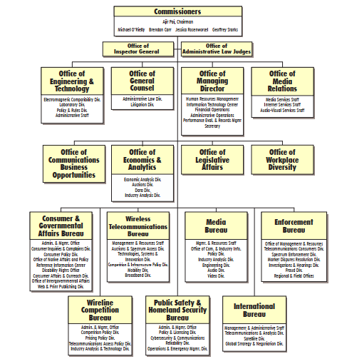
Source: https://www.fcc.gov/about-fcc/organizational-charts-fcc

Question 4
ITU is an abbreviation for the International Telecommunication Union and agency of the United Nations, whose principal purpose is to coordinate all telecommunication operations as well as services across the globe. ITU was established in 1865 under the name international Telegraph union. The primary specific areas within the ICT covered by ITU include the radiocommunication, telecommunication standards, and telecommunication development.
The ITU generates standards that are fundamental to the operations of today's ICT networks across the globe. In the event, ITU standards were missing; one could not make a telephone call as well as browse the internet. This is because it maintains the interference-free operations of the radiocommunications systems across the globe. The space services are utilized to monitor as well as transmit the changes concerning ocean temperatures, vegetation patterns alongside greenhouse gases to assist in the prediction of famines, hurricanes paths, and global climate changes. They utilize the explosive growth of wireless communications to offer broadband services, portray the urge for global solutions as well as address the needs for additional radio spectrum allocations while generating some harmonizing standards to better the interoperability (Qian et al., 2017).

The ITU organizational structure is shown in figure 2.
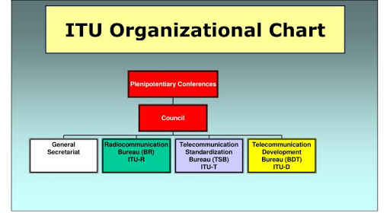
Source: https://www.google.com/url?sa=i&url=http%3A%2F%2Fwww.presentica.com%2Fppt-presentation%2Fitu-bdt-exercises-identified-with-teletraffic-designing&psig=AOvVaw1XxYnVXvtVwuO7ppiQUXXQ&ust=1584921475421000&source=images&cd=vfe&ved=0CAIQjRxqFwoTCLCxguDirOgCFQAAAAAdAAAAABAI

Question 5: Importance of Saudi CITC for the ICT sector in Saudi Arabia
The Communications and Information Technology Commission CTIC) plays a hand in the celebrations regarding the world telecommunication and information society Day (WTISD-17) that happens on May 17th every calendar year since it exhibits the capabilities to convert theoretical data to practical information across all the fields (Al Hamed, and Alenezi, 2016).
The CITC was established by the Telecommunications Act in 2001 with a primary mandate to regulate and oversee the country's ICT sector. It is also responsible for protecting consumers from price exploitations. CITC is required to monitor the ICT sector as well as the postal area in Saudi Arabia.

Question 6: The ISO, ETSI and other standard organizations and their importance to the ICT sector
The ISO is used to denote international organization for standardization that works with the standard Institutes across the globe with the primary objective of generating technology as well as product standards. ISO forms an integral part in the ICT world because it aids in the development of product specifications for products, services, systems as well as procedures through which they can measure the level of excellence.
The ETSI is among the leading standardization organizations for ICT standards that aids in fulfilling the European as well as global market needs. Its primary role is offered platforms to the willing parties to cooperate and work together to generate the ICT systems alongside the services that are used across the globe (Huovila, Bosch, and Airaksinen, 2019).

References
Al Hamed, T., & Alenezi, M. (2016). Business continuity management & disaster recovery capabilities in Saudi Arabia ICT businesses. International Journal of Hybrid Information Technology, 9(11), 99-126.
Faulhaber, G. R., Singer, H. J., & Urschel, A. H. (2017). Rebuttal of Reply to Our Paper “The Curious Absence of Economic Analysis at the Federal Communications Commission: An Agency in Search of a Mission. International Journal of Communication, 11, 2.
Huovila, A., Bosch, P., & Airaksinen, M. (2019). Comparative analysis of standardized indicators for Smart sustainable cities: What indicators and standards to use and when?. Cities, 89, 141-153.
Kanevskaia, O. (2019). Governance of ICT Standardization: Due process in technocratic Decision-making.
Luo, Y., & Bu, J. (2016). How valuable is information and communication technology? A study of emerging economy enterprises. Journal of world business, 51(2), 200-211.
Qian, Z., Li, B., Kang, L., Wang, T., & Wang, W. (2017). Classification of ITU Recommendations and Reports Base on IMT-2020 High Frequency Candidate Band EMC Analysis. International Journal of Communications, Network and System Sciences, 10(5), 163-169.

